Project Design Phase-II
Data Flow Diagram & User Stories
Project Name | AI StudyBuddy
Team ID | SWTID-2026-6718
Date | 27 September 2026

1. Data Flow Diagram

Level 0 / Level 1 Data Flow Diagram
AI StudyBuddy receives requests from students and admins through the frontend or an API client. Requests pass through JWT authentication and role checks before reaching the appropriate module. The system interacts with MongoDB for storing users and materials, with local disk storage for uploaded files, and with Google Gemini 2.5 Flash for AI-based summarization, flashcards, quiz and study-plan generation.

External Entities
- Student
- Admin
- Google Gemini AI Service

Main Processes
- 1.0 Authentication (Register / Login / Refresh / Logout)
- 2.0 Study Material Upload & Management
- 3.0 AI Generation (Summary / Flashcards / Quiz / Study Plan)
- 4.0 Admin Management (Users / Stats)

Data Stores
- D1: Users (MongoDB)
- D2: Materials (MongoDB)
- D3: Local Uploads Storage
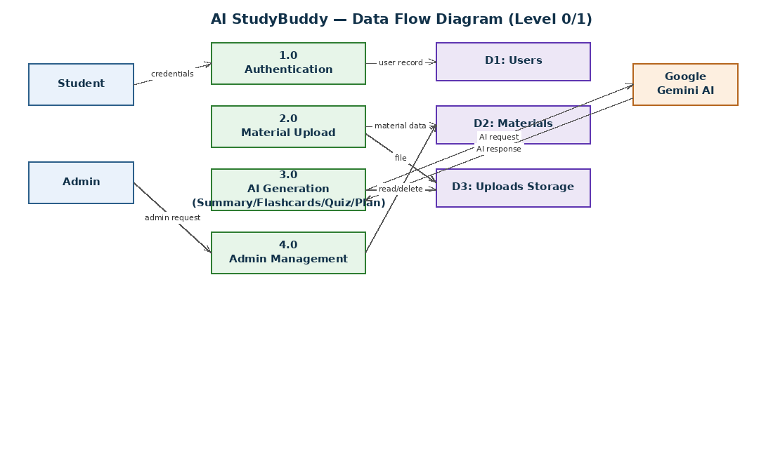
Figure 1: AI StudyBuddy Data Flow Diagram (Level 0/1)

2. User Stories
The template requires the user type, functional requirement/epic, user story number, user story/task, acceptance criteria, priority, and release.
User Type | Functional Requirement (Epic) | USN | User Story / Task | Acceptance Criteria | Priority | Release
Student | Registration | USN-1 | As a student, I can register using my name, email, password and role. | A new account is created with a securely hashed password. | High | Sprint-1
Student | Login | USN-2 | As a student, I can log in using my email and password. | Valid credentials return JWT access and refresh tokens. | High | Sprint-1
Student | Session Management | USN-3 | As a student, I can refresh my session without logging in again. | A valid refresh token returns a new access token. | Medium | Sprint-1
Student | Material Upload | USN-4 | As a student, I can upload a study file (.txt/.md/.pdf) with a title. | The file is parsed and stored as a Material linked to my account. | High | Sprint-2
Student | Material Management | USN-5 | As a student, I can view a list of all my uploaded materials. | Only my own materials are returned. | High | Sprint-2
Student | Material Management | USN-6 | As a student, I can view or delete a specific material. | Only the owner can view/delete their material. | Medium | Sprint-2
Student | AI Summarization | USN-7 | As a student, I can generate an AI summary of a material. | A concise summary is generated via Gemini and saved to the material. | High | Sprint-3
Student | AI Flashcards | USN-8 | As a student, I can generate a set number of flashcards from a material. | Question/answer pairs are generated and returned. | High | Sprint-3
Student | AI Quiz | USN-9 | As a student, I can generate an MCQ quiz from a material. | Quiz questions with options and correct answers are generated. | High | Sprint-3
Student | AI Study Plan | USN-10 | As a student, I can generate a personalized study plan given a goal, hours/day and days. | A day-wise plan is generated based on my inputs and material. | Medium | Sprint-4
Admin | User Management | USN-11 | As an admin, I can view a list of all registered users. | Only role=admin can access this endpoint. | Medium | Sprint-4
Admin | User Management | USN-12 | As an admin, I can delete a user along with their materials. | The user and all linked materials are removed. | Medium | Sprint-4
Admin | Platform Stats | USN-13 | As an admin, I can view total user and material counts. | Aggregate counts are returned correctly. | Low | Sprint-4

